Would you please send me the Microsoft Word Form(s) that your festival uses to gather data?

Here is the link <https://forms.gle/RXxXzLh5LbqpVvbn7>

Also, can you please confirm or correct the following assumptions?

1. The teachers and parents have the syllabus, which is created separately from the MFO program
   1. It is created separately and them put into MFO. Under setup>syllabus>the classes are entered manually from the syllabus The syllabus is posted on our web site [www.peikmfa.ca](http://www.peikmfa.ca/). Under Queens you will see that I put up a syllabus for Queens that shows divides of classes according to age and it lists the fees we charge. The main syllabus is the classes and pertinent information required for entries.
2. The syllabus information is not stored in or accessible from the MFO program
   1. Syllabus information is stored and accessible from the MFO program
3. The teachers create all entries in the MFO program.
   1. Some teachers enter all there students, some don’t

    a) Parents do not create entries. Parents can enter their children

    b) Students do not create entries.Students can create entries

1. If a student has more than one teacher, each teacher creates their own entry for that student
   1. The way it is now, we have one entry for each student, i.e. The student enters his/her string classes and puts in the teachers name
   2. The student can continue to enter their piano entries and put in that teachers name. We have added a drop down list of teacher for the students to choose from. Sometimes a new teachers’ name is not in the list so they click “other” and I enter the teacher manually under Set up>teachers

    a) This might create a scenario where the same student is represented in the MFO program twice and that will be manually corrected by the MFO user Not usually, occasionally it gets wonky.

And answer the following questions

1. After event registration is closed, the schedule is created. What tools do you use to create the schedule?
   1. 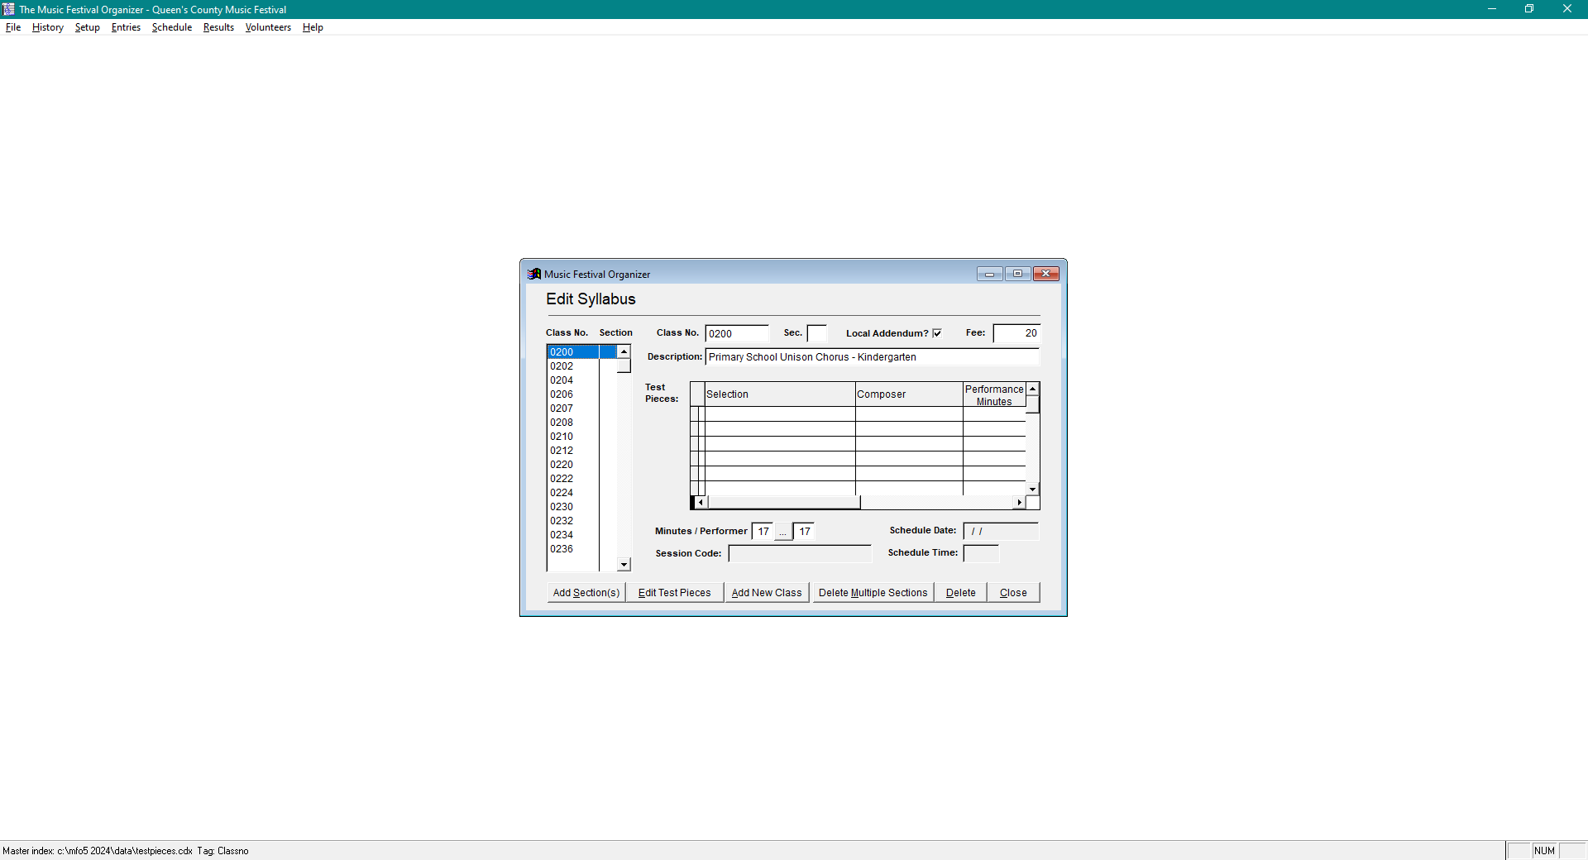Under entries I print the “Summary of Entries by class #” report. This prints out all the entries by class number. I then manually calculate the time for each class. If MFO could pick up the “length of performance” then I would not have to do that. When we set up the syllabus we put in a number indicating “minutes/performer”. We have 7 minutes for adjudication for 17 years and under etc. The problem is MFO does not pick up the time of the repertoire, some sonatas/concertos are 25 minutes long. Our timing for that student would be out 25 minutes if we did not manually add it on.

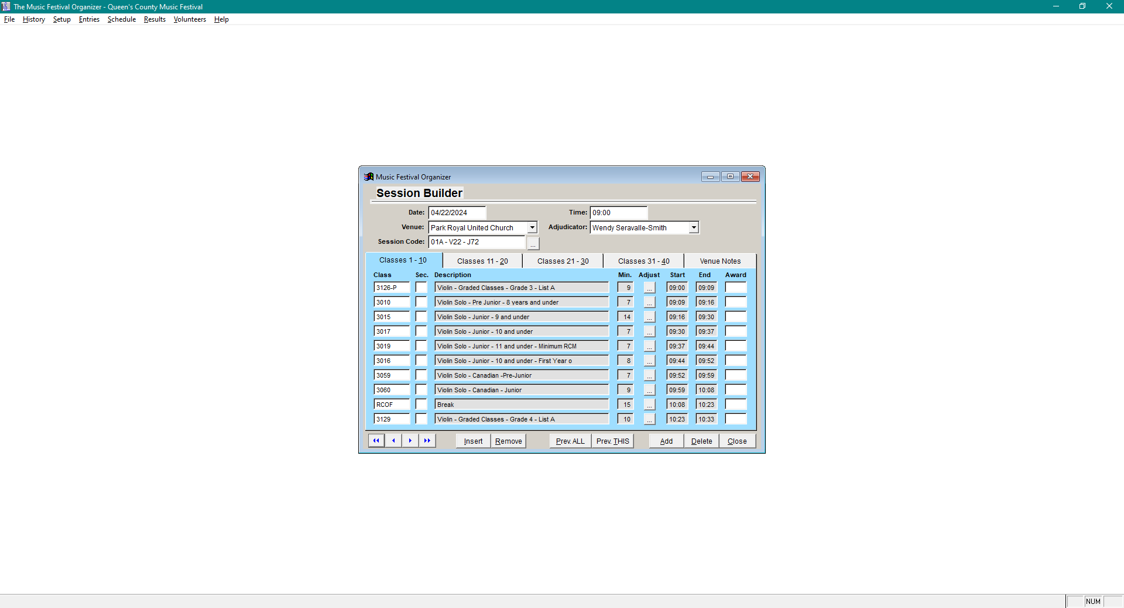

1. Does MFO eventually create or  import schedule information so you can use it to generate reports?

This is the session builder. Once I have the classes tabulated I then manually arrange them into sessions and enter the sessions manually.

Next step (under schedule) is go to Reports> check for errors etc. etc. Just follow the prompts.

The program will print but comes out as a pdf.

I send out confirmation reports to accompanists, teachers, and a participant if they request it.

I hope I have made my response clear.

Entries are now closed but the entry link seems to work enough to let you see how we gather information.

Thanks for all you hard work.

Mom